Liturgical Dance Camp
Choreographer Katie Schultz
June 25, 26, 27 (Tuesday, Wednesday, Thursday)
Ages 5-7 Ages 8-16
9:00-11:00am 1:00-3:00pm
*Ages in each group might be adjusted once we have a better headcount

June 28 (Friday)
All ages 9:00-11:00

All participants expected to dance in worship June 30 at 9:30.

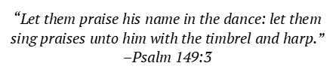
- FPC will provide dance clothing. Help us ensure we have correct sizes for each dancer; See chart attached and select the size that corresponds your child’s largest measurement (waist, hips, height, and girth). *NOTE: Dance clothing does not always use the same sizing as regular sizes.
- Each age group will learn their own dance and a combined-age dance.
- Each dance session will include a devotion/prayer time and a snack. Participants will be encouraged to bring a snack to share on assigned day.
Registration Deadline is June 2
First Presbyterian Church 2300 S West Ave, Sioux Falls, SD 57105

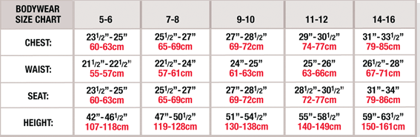
BOYS SIZING CHART

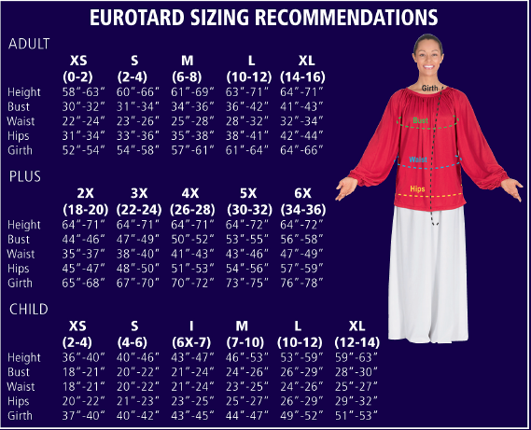
GIRLS SIZING CHART

